**PLM EASI Portal Application Known ISSUES:**

1. **Formats Available works inversely.**

**When using the Formats available check box, selecting it the first time does not select all the documents as intended:**

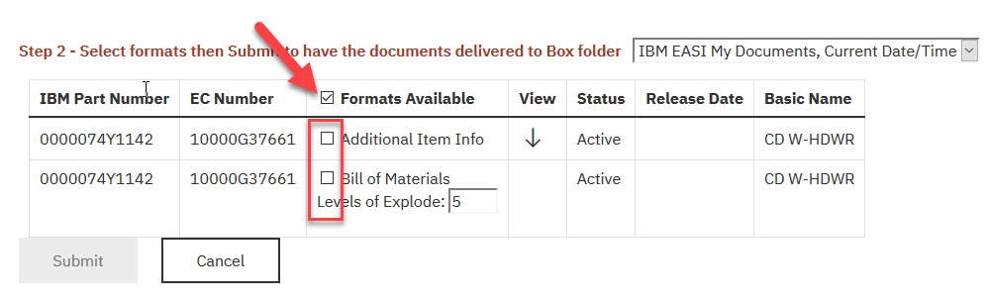

**You must select it again to select all:**

